Olusegun Afolabi
EECE 412
Professor Wenjie
2/11/2025
Lab 3
Introduction
This lab focuses on implementing and analyzing an indexed assignment within a process block using VHDL. The primary objective is to create a testable design in Vivado, understand its schematic representation, and verify correct functionality through FPGA programming on the Basys 3 board.
Tools and Applications Used
- Vivado Design Suite: Used for project creation, design entry, synthesis, and implementation.
- VHDL: The hardware description language used to implement the indexed assignment.
- Basys 3 FPGA Board: The target hardware platform used to verify real-world implementation.
- Simulation and Hardware Debugging: Performed using Vivado's Open Elaborated Design and FPGA testing.
Part 1: Procedure
- Created the project in Vivado as instructed, ensuring to select VHDL and the Basys 3 board.
- Copied the provided process block and created a design file.
- Added the design file to the project and included the Basys 3 constraint file.
- Clicked Run Linter, then selected Open Elaborated Design to view the schematic.
- Took a screenshot of the schematic and identified its components in relation to the process block.
- Edited the constraint file to map sw[0:1] to ctrl and LED[0:3] to a.
- Synthesized the design.
- Ran the implementation of the design.
- Generated the bitstream, connected the board, and programmed the FPGA.
- Performed the required tests and captured snapshots of the results.
Part 1: Questions and Responses
- Identify Components of the Schematic That Correspond to the Process Block in the VHDL Code
The schematic from "Open Elaborated Design" represents the process block in the VHDL code as follows:
VHDL Code | Schematic Representation
au <= (others => '0'); | Grounded input (I) initializes au to 0000.
au(to_integer(unsigned(ctrl))) <= '1'; | Implemented as an RTL multiplexer (RTL_BMERGE).
a <= std_logic_vector(au); | Output O[3:0] feeds directly into a[3:0].

Breakdown of Components in the Schematic
- Input Control Signal (ctrl[1:0])
  - Acts as a 2-bit selector (S[1:0]) that determines which bit in a[3:0] is set.
- RTL_BMERGE Block
  - Functions like a multiplexer:
    - Initializes all bits to 0.
    - Sets the bit indexed by ctrl to 1.
    - The DATA[3:0] input represents the 4-bit register (au).
- Grounded Input (I)
  - Ensures that au starts at 0000 before any changes occur.
- Final Output (a[3:0])
  - The O[3:0] output corresponds to a[3:0], reflecting the final processed value.
- Identify and Explain All Instances of Type Conversion and Type Casting in the Process Block
The process block contains three significant type conversions:
- Conversion from std_logic_vector to unsigned
to_integer(unsigned(ctrl))
  - ctrl is a std_logic_vector(1 downto 0).
  - unsigned(ctrl) converts it into an unsigned type to allow arithmetic operations.
  - to_integer(...) converts the unsigned value to an integer, enabling index-based assignment.
- Indexed Assignment in au
au(to_integer(unsigned(ctrl))) <= '1';
  - Assigns 1 to a specific bit in au, determined dynamically by ctrl.
  - Since indexing requires an integer, ctrl is first converted before being used.
- Conversion from unsigned to std_logic_vector
a <= std_logic_vector(au);
  - au is of type unsigned(3 downto 0).
  - std_logic_vector(au) converts it back to std_logic_vector(3 downto 0), so it can be assigned to a.

Part 1: Simulation and Results
The following images display the results of hardware testing on the Basys 3 FPGA:
- All Switches Off → Output: 0000
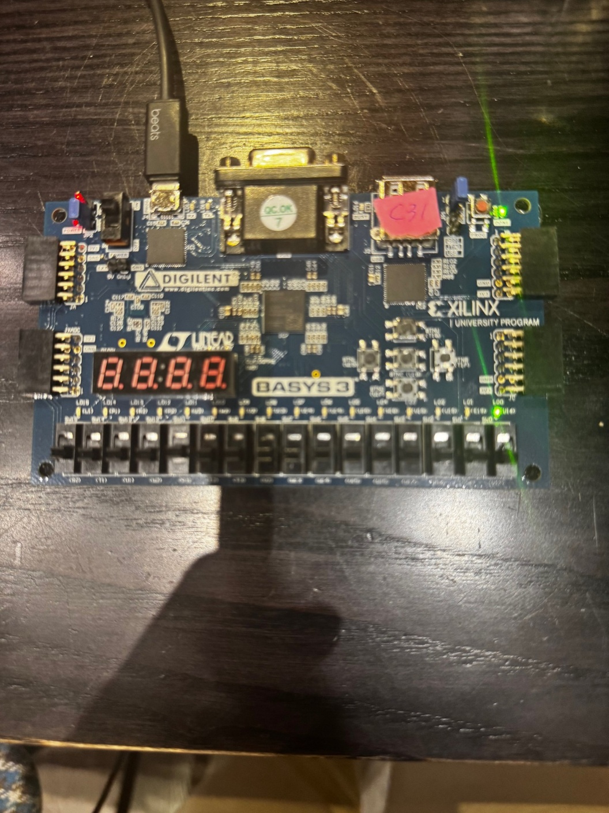
- Switch sw[0] On → Output: 0001
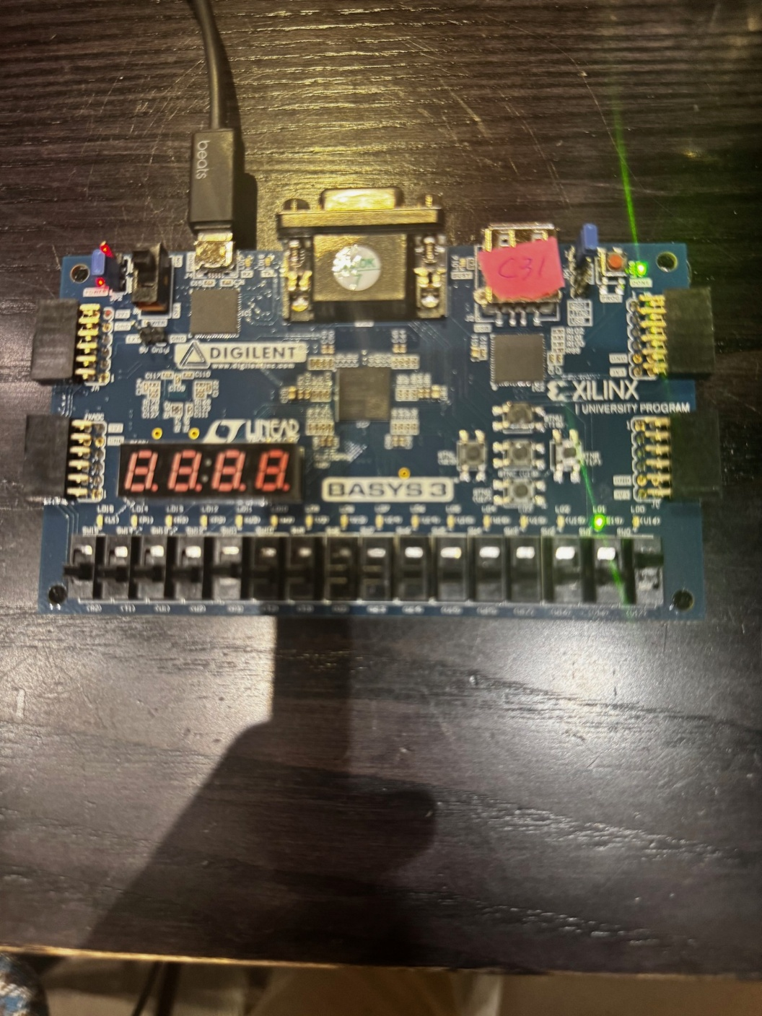
- Switch sw[1] On → Output: 0010
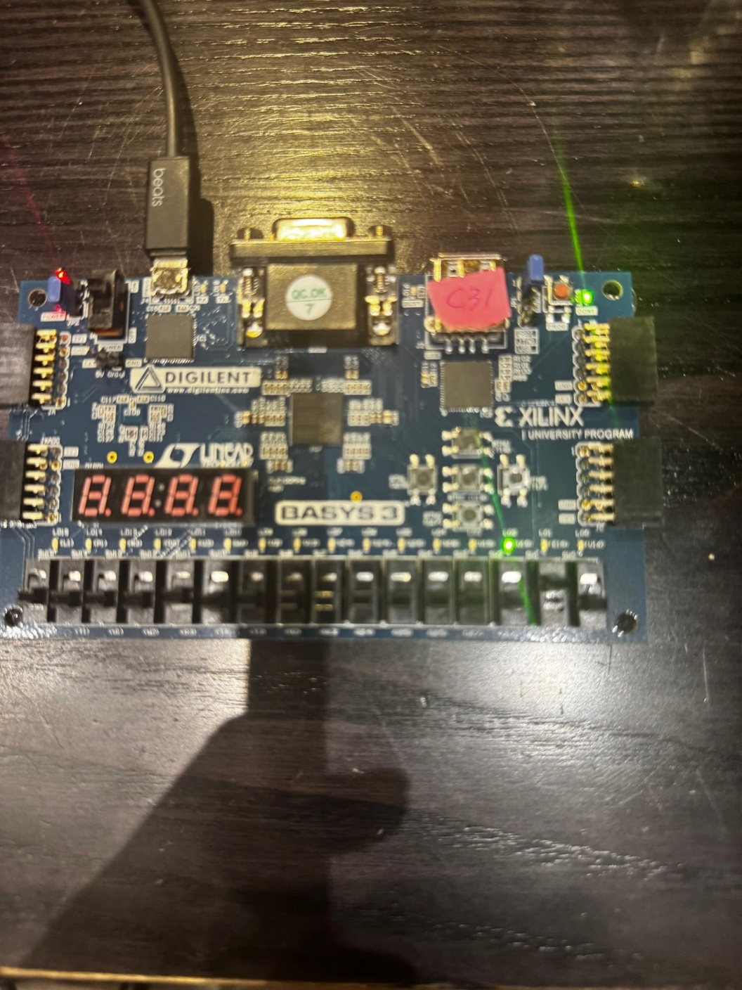
- Switch sw[0:1] On → Output: 0011
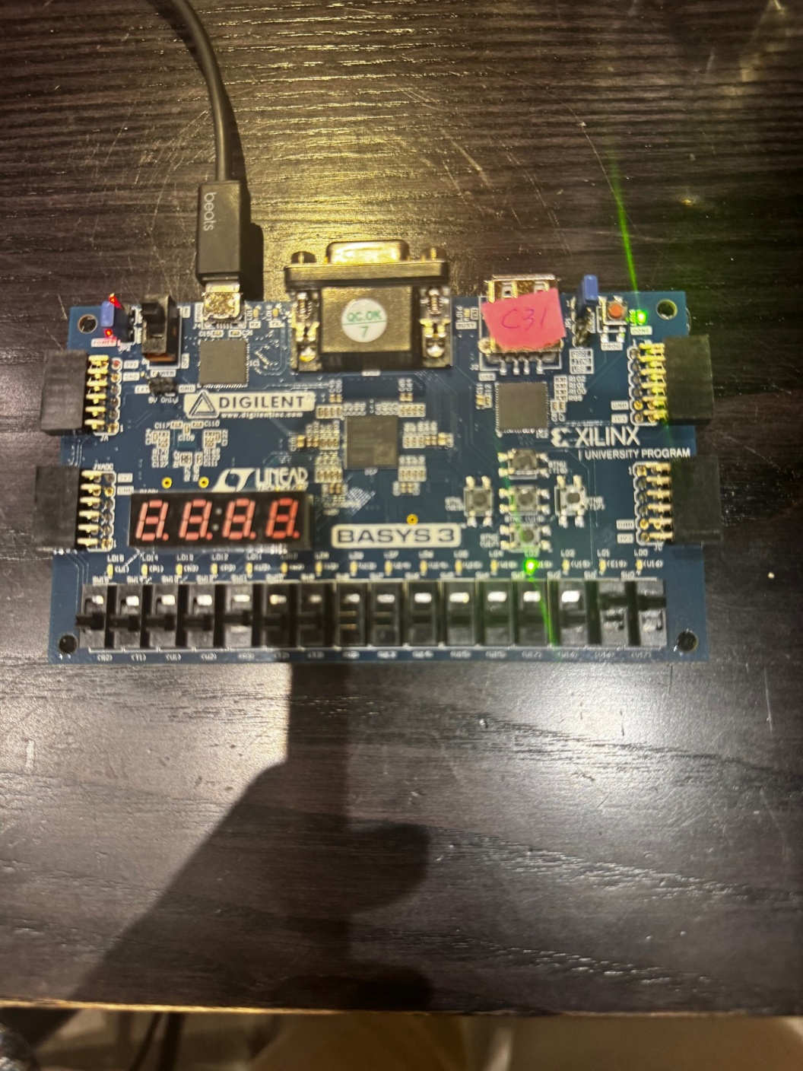
These results match the expected behavior, demonstrating that the design correctly assigns 1 to the bit index selected by ctrl.

Part 2: Procedure
- Modified the VHDL code by adjusting ctrl to 2:0, adjusting au and a to 7:0. Added comments to the code explaining the modifications.
- Modified the constraint file by applying sw[0:2] to ctrl and LED[7:0] to a.
- Ran Linter and reloaded the elaborated design for a new schematic.
- Analyzed the new schematic and identified the components in the schematic and how they relate to the process block.
- Synthesized the design.
- Ran the implementation of the design.
- Generated the bitstream, connected the board, and programmed the FPGA.
- Performed the tests as instructed and took snapshots of the results.
Part 2: Questions and Responses
1. Identify Components of the Schematic That Correspond to the Process Block in the VHDL Code
- Input Control Signal (ctrl[2:0])
  - In the VHDL code, ctrl is a 3-bit input (std_logic_vector(2 downto 0)) that determines which bit in a[7:0] is set to 0.
  - In the schematic, ctrl[2:0] is represented as the S[2:0] input to the RTL_BMERGE component.
  - Function: ctrl acts as the selector for which bit in a[7:0] will be modified.
- RTL_BMERGE Block (Implements Indexed Bit Selection)
  - This multiplexer-like component implements the indexed bit modification.
  - DATA[7:0] represents the au signal, which starts with all bits set to 1.
  - The I input (grounded) represents the default initialization to 1s in the process block:
au <= (others => '1');
  - The S[2:0] input corresponds to ctrl, selecting which bit in DATA[7:0] will change.
  - Function: It modifies au by setting the indexed bit (selected by ctrl) to 0:
au(to_integer(unsigned(ctrl))) <= '0';
- Output a[7:0] (Final Modified Output)
  - In the VHDL code, the final assignment to a is:
a <= std_logic_vector(au);
  - In the schematic, this is represented as O[7:0] from the RTL_BMERGE block.
  - The final output signal a[7:0] is connected to LEDs (LD7-LD0) on the FPGA.

Part 2 Results:
The 8-bit implementation (a[7:0]) was successfully tested with different switch combinations, confirming that the indexed bit was correctly modified to 0:
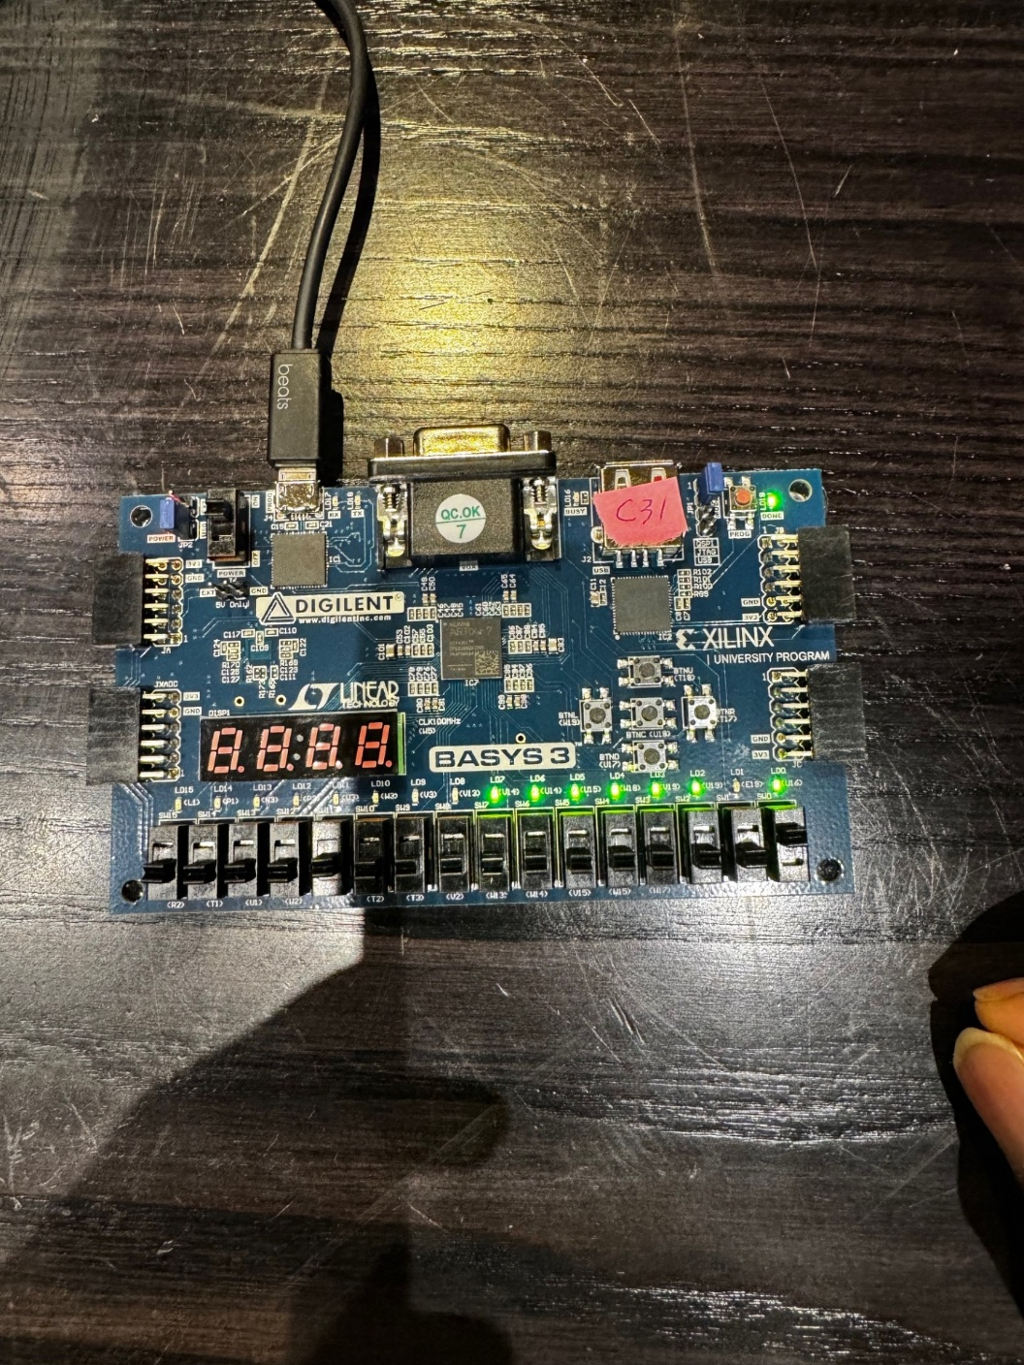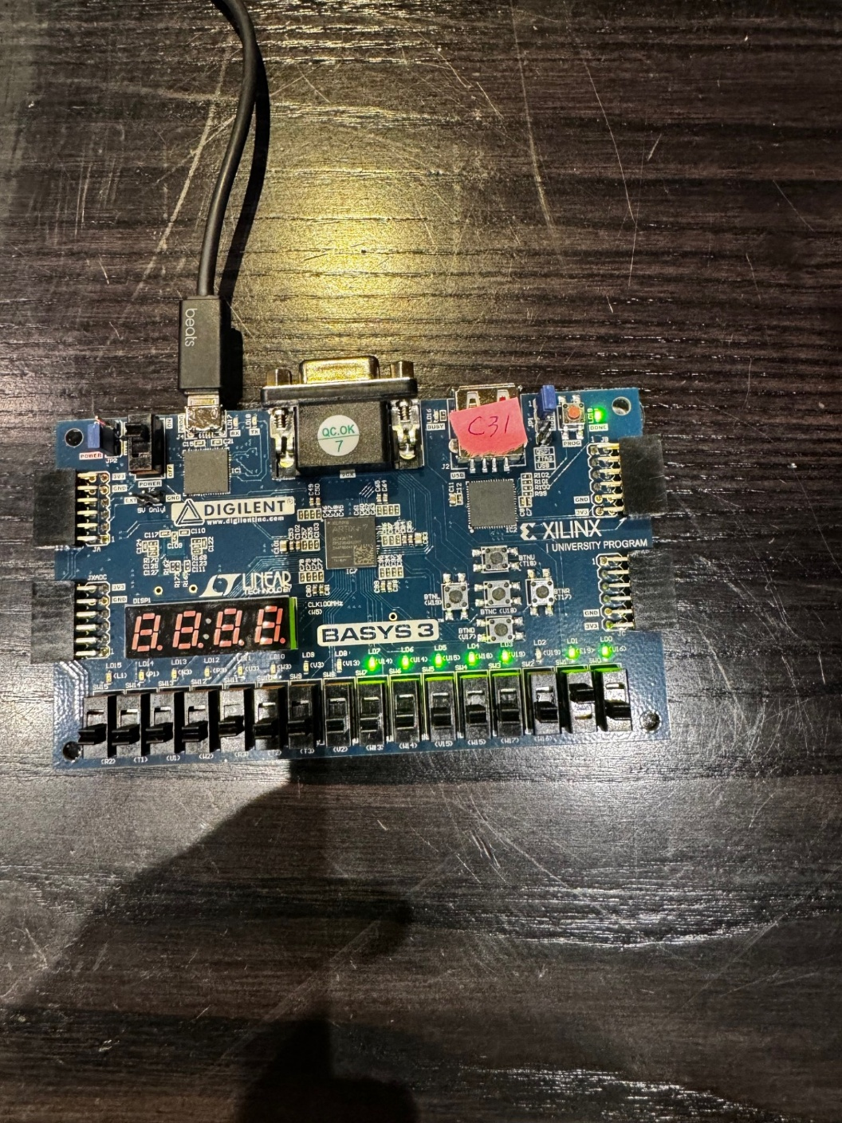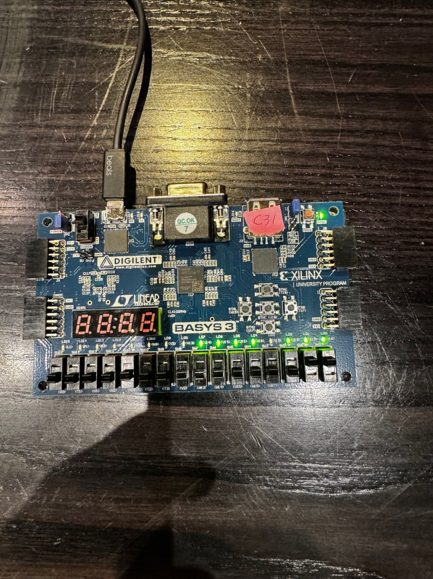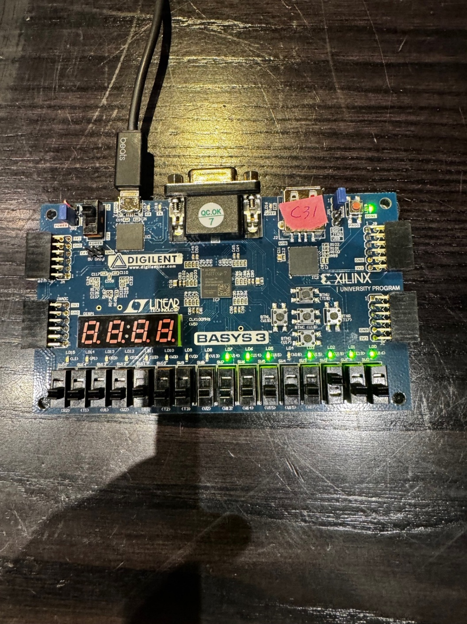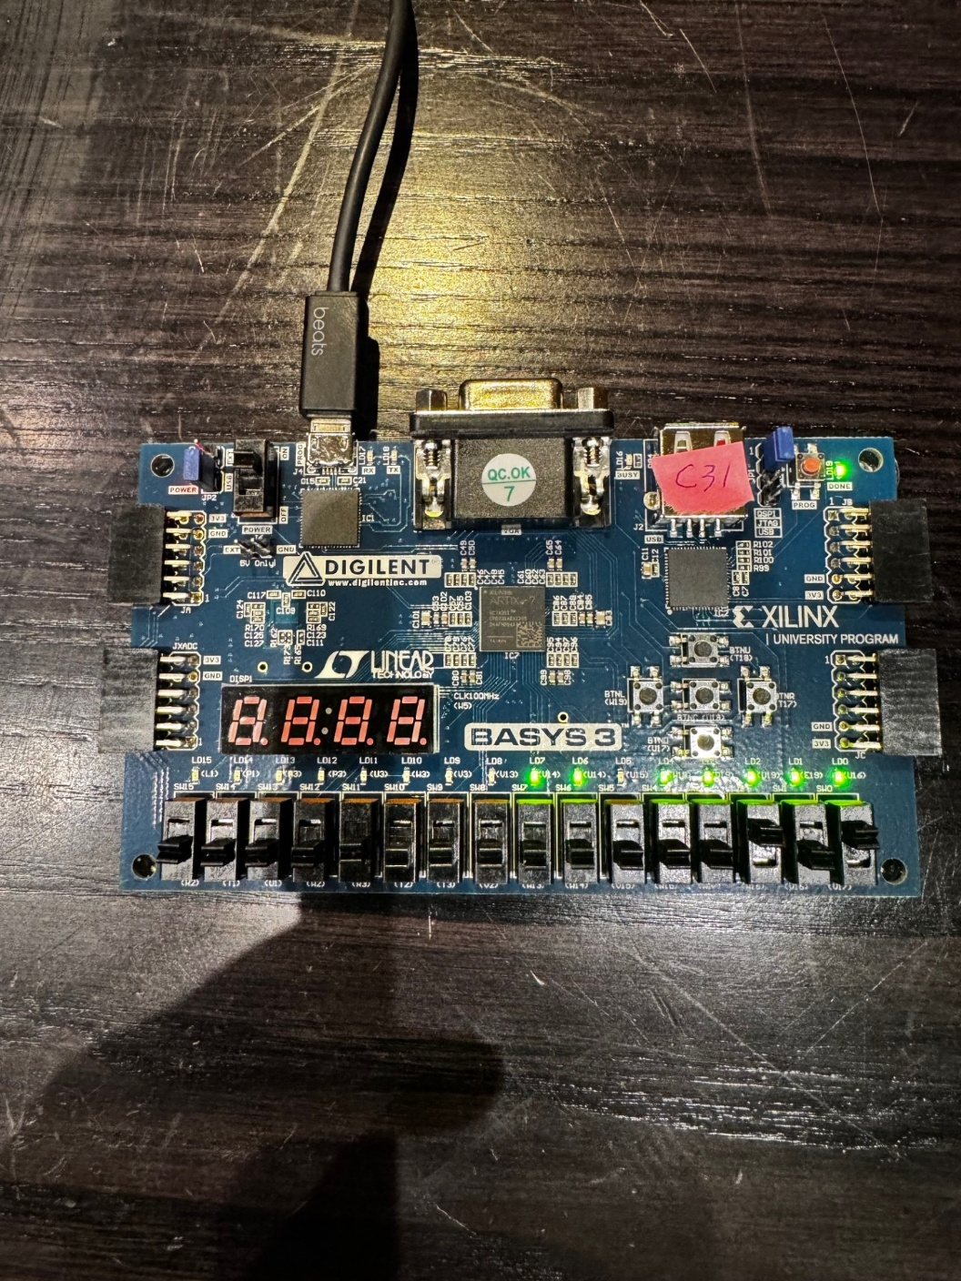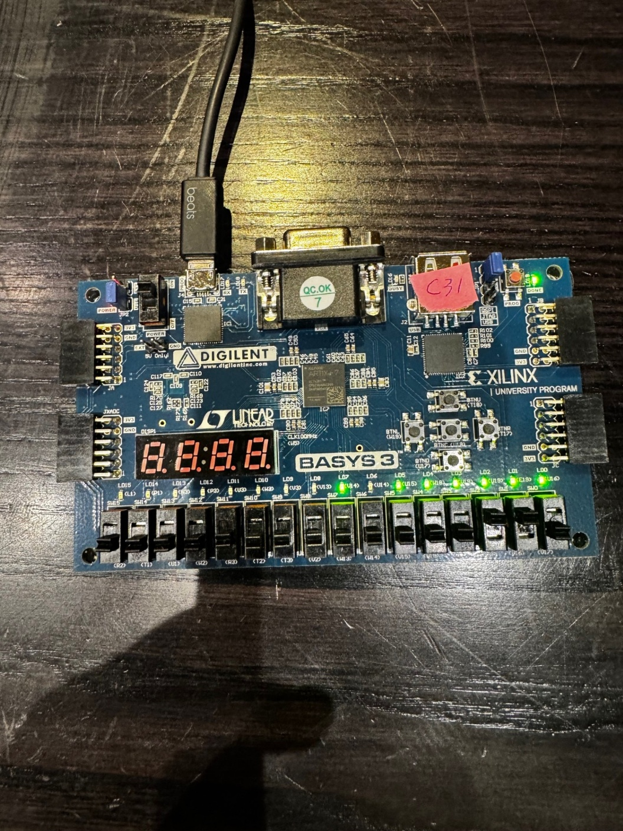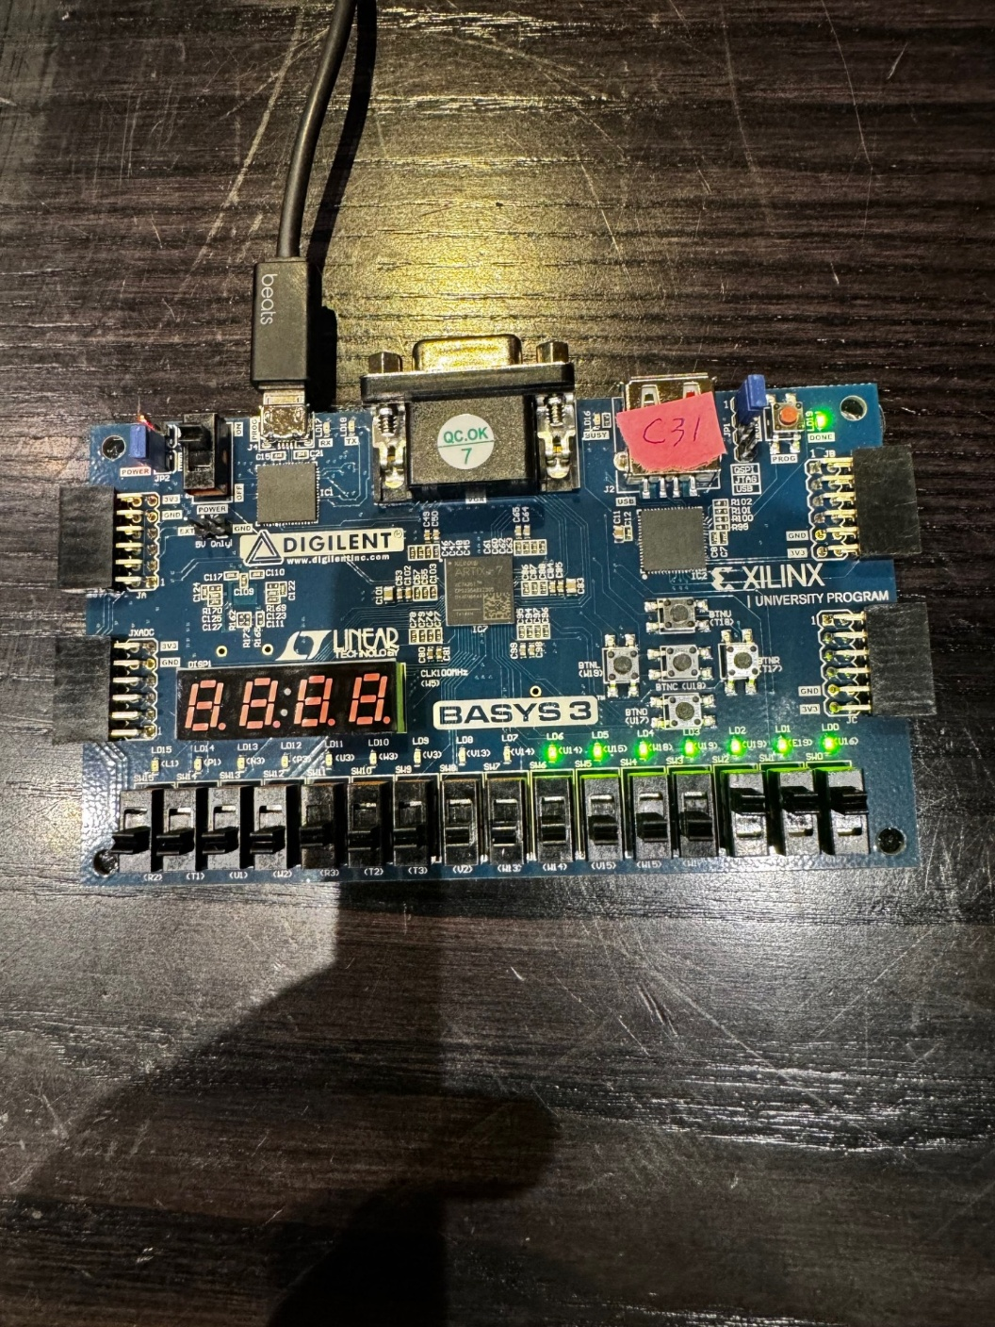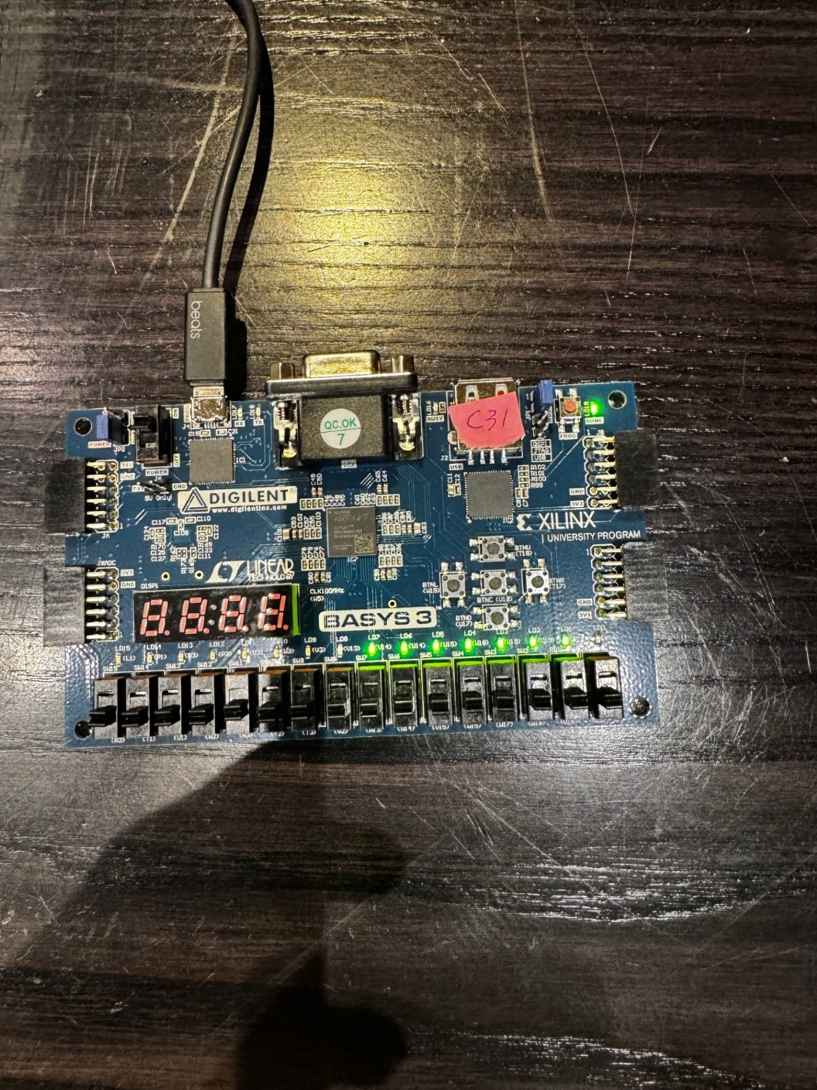
Switch Configuration | Expected Output | Observed Output
All Switches Off | 11111111 | 11111111
sw[0] On | 11111110 | 11111110
sw[1] On | 11111101 | 11111101
sw[2] On | 11111011 | 11111011
sw[0:1] On | 11111100 | 11111100
sw[1:2] On | 11111010 | 11111010
sw[0:2] On | 11111000 | 11111000
All Switches On | 11111000 | 11111000

Conclusion
This lab successfully implemented and verified an indexed assignment using VHDL in both Part 1 and Part 2.
Key Takeaways:
- Part 1:
  - Demonstrated how a 2-bit ctrl input determines which bit in a[3:0] is set.
  - Successfully mapped the process block to its corresponding RTL schematic components.
  - Verified outputs using FPGA implementation and hardware testing.
- Part 2:
  - Expanded the indexed assignment to an 8-bit register (a[7:0]) controlled by a 3-bit ctrl.
  - Modified constraint files to match the new design specifications.
  - Verified outputs through FPGA testing, confirming correct indexed bit modification.
Overall, the experiment deepened the understanding of indexed assignments, type conversion, and schematic representation of VHDL code. The results aligned with expected behaviors, confirming the correct functionality of the even_detector circuit. This knowledge serves as a foundation for more advanced digital design concepts in future labs.
The lab successfully modified and verified the indexed assignment process with an expanded bit range. FPGA testing confirmed the expected behavior, reinforcing concepts of bit selection and indexed operations in VHDL.

